Your Title Appears Here on the Very First Line (12 pt. Time New Roman Regular)
(Leave one blank line here!)
First Author (10 pt. Times New Roman Regular)
First Author’s Affiliation (10 pt. Times New Roman Italics)
Email: …………….. (10 pt Times New Roman Regular)
(Leave one blank line here!)
Second Author (10 pt. Times New Roman Regular)
Second Author’s Affiliation (10 pt. Times New Roman Italics)
Email: …………….. (10 pt Times New Roman Regular)
(Leave one blank line here!)
Third Author (10 pt. Times New Roman Regular)
Third Author’s Affiliation (10 pt. Times New Roman Italics)
Email: …………….. (10 pt Times New Roman Regular)
(Leave one blank line here!)

- Introduction
The introduction section should include a brief background of the research (or study) done including citation of a few reference papers. Why this research/study is important should also be clearly described along with clear a problem statement. It should also include a set of research objectives.
Use 10 pt. Time New Roman Regular fonts for the whole body text starting from ‘Introduction’ to the list of references. Single line spacing should be used all throughout the body text. If relevant, a picture or a figure may also be included in the introduction section, but the width of the picture/figure must be equal to the column width or the page width. For example, a figure equal to the column width should be inserted as follows (Fig. 1).

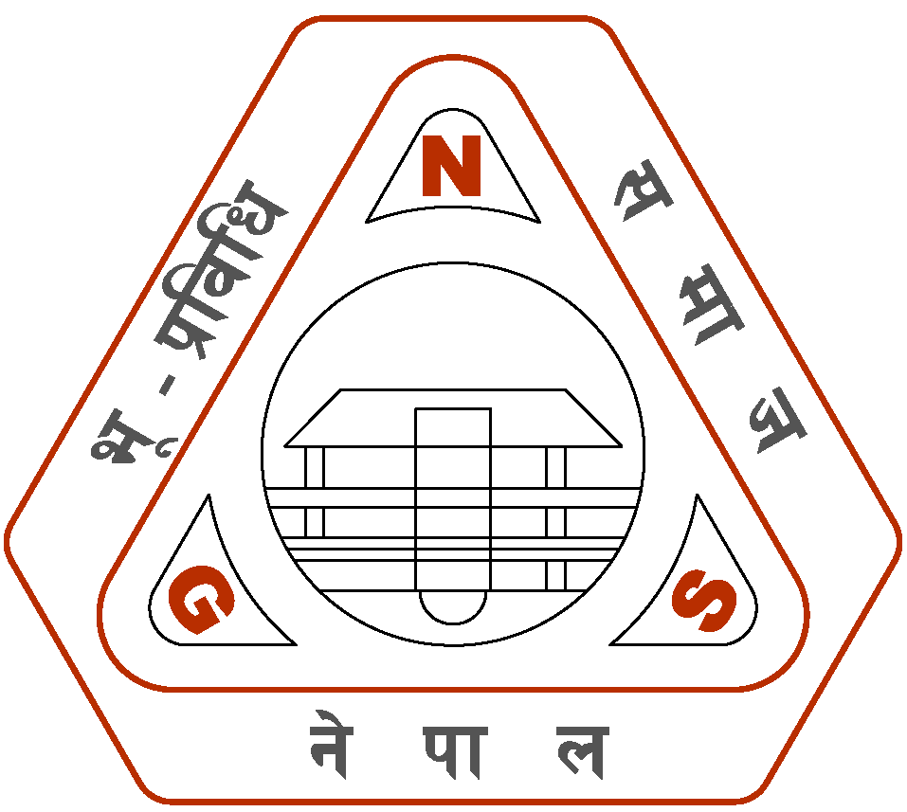
Fig. 1: The logo of Nepal Geotechnical Society.

- Material and Method (Methodology)
In case of a research paper, the material method must be clearly described. If it is a case study, the study area and the method employed must be described well.
A data table, if necessary must be inserted as follows (Table 1).

Table 1: Age group of NGS members.
Age group | No. of members
25-50 | 150
50-70 | 45
>70 | 5

This section must clearly state what was done and how it was done.

- Results and Discussion
This section must include the results obtained and their clear description. The relevancy of the results obtained must also be well justified and discussed with reference to any previously published work and results. Enough citation of reference papers may also be made here in this section.
It is very important that this section makes the core part of the work done. One or two figures that support the logic and discussion made must also be included (e.g., Fig. 2).

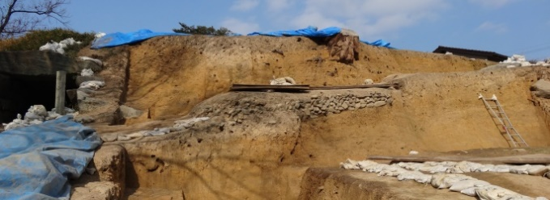
Fig. 2: A photo showing a massive roadside cut slope.

- Concluding Remarks
The concluding remarks must include a brief review of the work done and the results obtained. Then, what has been understood from the obtained results must be briefly stated based on the discussion made. It is important that research objectives set in the introduction section must be well addressed here in the conclusions. In a sense, the concluding remarks alone should make the readers understand what was done and what has been understood.

Acknowledgement (if any)
Please include an acknowledgement, if necessary, but limit it within a few lines.

References
Please include at the most 4 most important references papers that are relevant to your research work. It is necessary that you cite all the papers listed here in your body text. Please follow any standard for the reference paper listing and citation.

(Note: Please try to fill at least 80% of this page!)

